Lab 4 - Inserting Initial Data into the Database
Step 1: Inserting Data in Program.cs (code snipppet)–
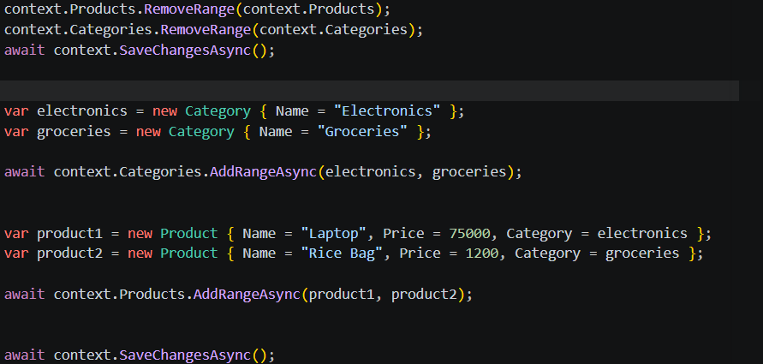
Step 2: Run App (output) –
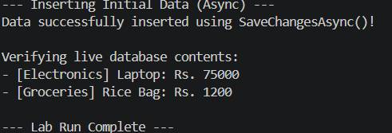
Step 3: Verifying in SQL Server (online tool):
